CSA47 – Deep Learning
Name: Thikkavarpu Sanhith Register No.: 192311228

Experiment 5: Bias–Variance, Overfitting and Underfitting Analysis
Question
Problem Statement: A real-estate start-up predicts house prices from floor area. One analyst’s model is too simple; another memorises the training data. 150 noisy samples of house area versus price, with a hidden non-linear relationship. The objective is to demonstrate underfitting, good fit and overfitting, and estimate bias and variance. Use Scikit-learn, NumPy, Matplotlib.
Tasks:
- Fit polynomial regression of degree 1, 3, 9 and 15 with Scikit-learn.
- Plot each fitted curve over the data.
- Plot training and validation error against model complexity.
- Estimate bias² and variance through repeated resampling.
- Select the best degree and justify it.
Code
"""Experiment 5: Bias-Variance, Overfitting and Underfitting Analysis"""
import numpy as np
import matplotlib.pyplot as plt
from sklearn.preprocessing import PolynomialFeatures, StandardScaler
from sklearn.linear_model import LinearRegression
from sklearn.pipeline import make_pipeline
from sklearn.model_selection import train_test_split
from sklearn.metrics import mean_squared_error

rng = np.random.RandomState(42)

def true_fn(area): # hidden non-linear relationship
u = (area - 500) / 3000
return 100 + 150 * np.sin(2.5 * u) + 60 * u

area = rng.uniform(500, 3500, 150)
price = true_fn(area) + rng.normal(0, 15, 150) # noisy price (in lakhs)
X = area.reshape(-1, 1)
X_tr, X_val, y_tr, y_val = train_test_split(X, price, test_size=0.3, random_state=1)
grid = np.linspace(500, 3500, 300).reshape(-1, 1)

def make_model(d):
return make_pipeline(PolynomialFeatures(d, include_bias=False), StandardScaler(), LinearRegression())

# ---- Tasks 1 & 2: fit degrees 1, 3, 9, 15 -------------------------------
fig, ax = plt.subplots(2, 2, figsize=(12, 8)); ax = ax.ravel()
for a, d in zip(ax, [1, 3, 9, 15]):
m = make_model(d).fit(X_tr, y_tr)
a.scatter(X_tr, y_tr, s=12, label="train"); a.scatter(X_val, y_val, s=12, c="orange", label="validation")
a.plot(grid, m.predict(grid), "r", lw=2, label=f"degree {d}")
a.plot(grid, true_fn(grid.ravel()), "g--", label="true f")
a.set_ylim(price.min() - 50, price.max() + 50)
a.set_title(f"Degree {d}: train MSE={mean_squared_error(y_tr, m.predict(X_tr)):.0f}, "
f"val MSE={mean_squared_error(y_val, m.predict(X_val)):.0f}")
a.set_xlabel("Area (sq ft)"); a.set_ylabel("Price"); a.legend(fontsize=8)
plt.tight_layout(); plt.show()

# ---- Task 3: error vs complexity ----------------------------------------
degrees = range(1, 16)
tr_err, val_err = [], []
for d in degrees:
m = make_model(d).fit(X_tr, y_tr)
tr_err.append(mean_squared_error(y_tr, m.predict(X_tr)))
val_err.append(mean_squared_error(y_val, m.predict(X_val)))
plt.figure(figsize=(7, 4.5))
plt.plot(degrees, tr_err, "o-", label="Training error")
plt.plot(degrees, val_err, "s-", label="Validation error")
plt.yscale("log"); plt.xlabel("Polynomial degree (complexity)"); plt.ylabel("MSE")
plt.title("Error vs model complexity"); plt.legend(); plt.grid(alpha=0.3); plt.show()

# ---- Task 4: bias^2 and variance via bootstrap --------------------------
B = 200
x_test = np.linspace(600, 3400, 100).reshape(-1, 1)
f_true = true_fn(x_test.ravel())
print(f"{'Degree':>6}{'Bias^2':>12}{'Variance':>12}{'Bias^2+Var':>13}")
bias2_list, var_list = [], []
for d in [1, 3, 9, 15]:
preds = np.zeros((B, len(x_test)))
for b in range(B):
idx = rng.choice(len(X_tr), len(X_tr), replace=True) # bootstrap resample
preds[b] = make_model(d).fit(X_tr[idx], y_tr[idx]).predict(x_test)
mean_pred = preds.mean(axis=0)
bias2 = np.mean((mean_pred - f_true) ** 2)
var = np.mean(preds.var(axis=0))
bias2_list.append(bias2); var_list.append(var)
print(f"{d:>6}{bias2:12.1f}{var:12.1f}{bias2 + var:13.1f}")

plt.figure(figsize=(7, 4.5))
xs = np.arange(4)
plt.bar(xs - 0.2, bias2_list, 0.4, label="Bias^2"); plt.bar(xs + 0.2, var_list, 0.4, label="Variance")
plt.xticks(xs, ["1", "3", "9", "15"]); plt.yscale("log"); plt.xlabel("Degree")
plt.title("Bias^2 and variance"); plt.legend(); plt.show()

# ---- Task 5: best degree -------------------------------------------------
best = list(degrees)[int(np.argmin(val_err))]
print(f"\nBest degree by validation error: {best} (val MSE = {min(val_err):.1f})")
print("Justification: lowest validation error; lower degrees underfit (high bias), "
"higher degrees overfit (high variance, train error << val error).")
Output
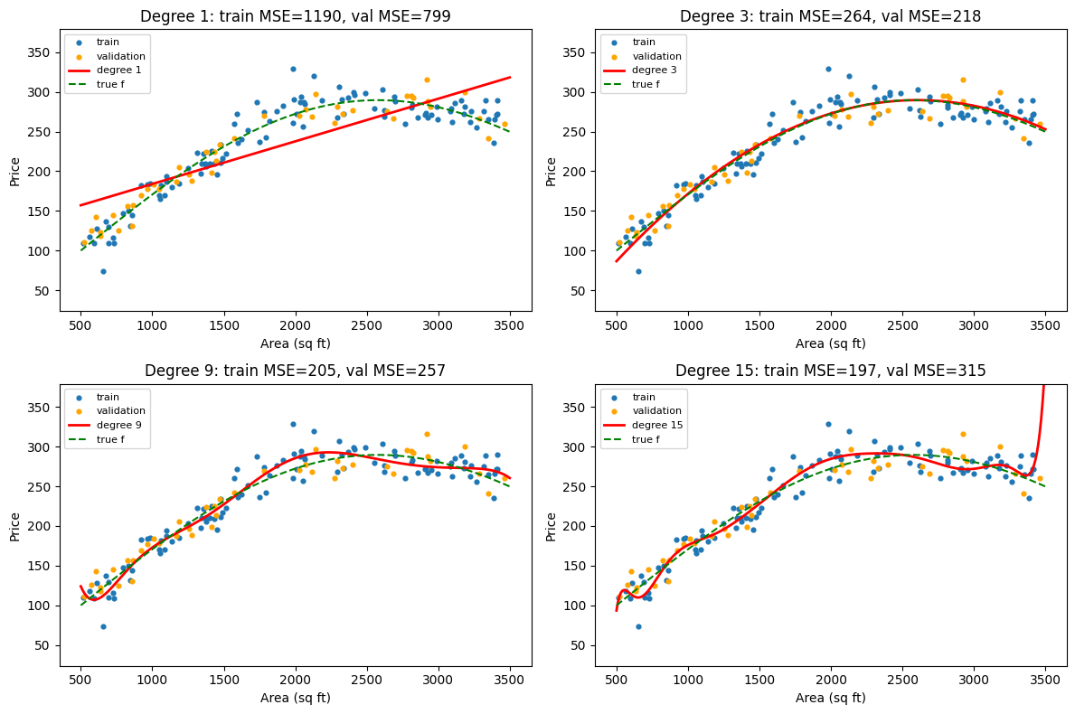
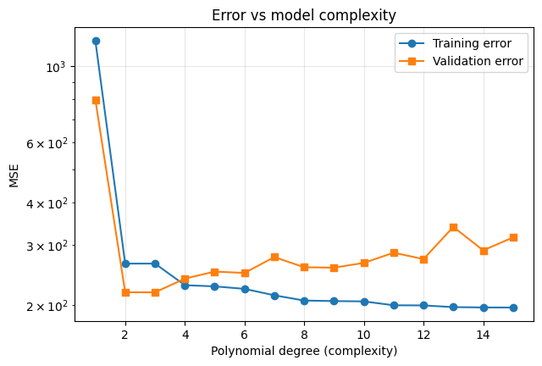
Degree Bias^2 Variance Bias^2+Var
1 729.4 22.8 752.2
3 6.8 9.8 16.7
9 46.9 18.8 65.7
15 55.7 45.6 101.2
